**Drones**

Drones are quickly becoming one of the U.S. military's primary weapons as the U.S. counterterrorism shifts from engaging in traditional, specified armed conflicts to targeting and killing individuals regardless of their location. Here's what you need to know.

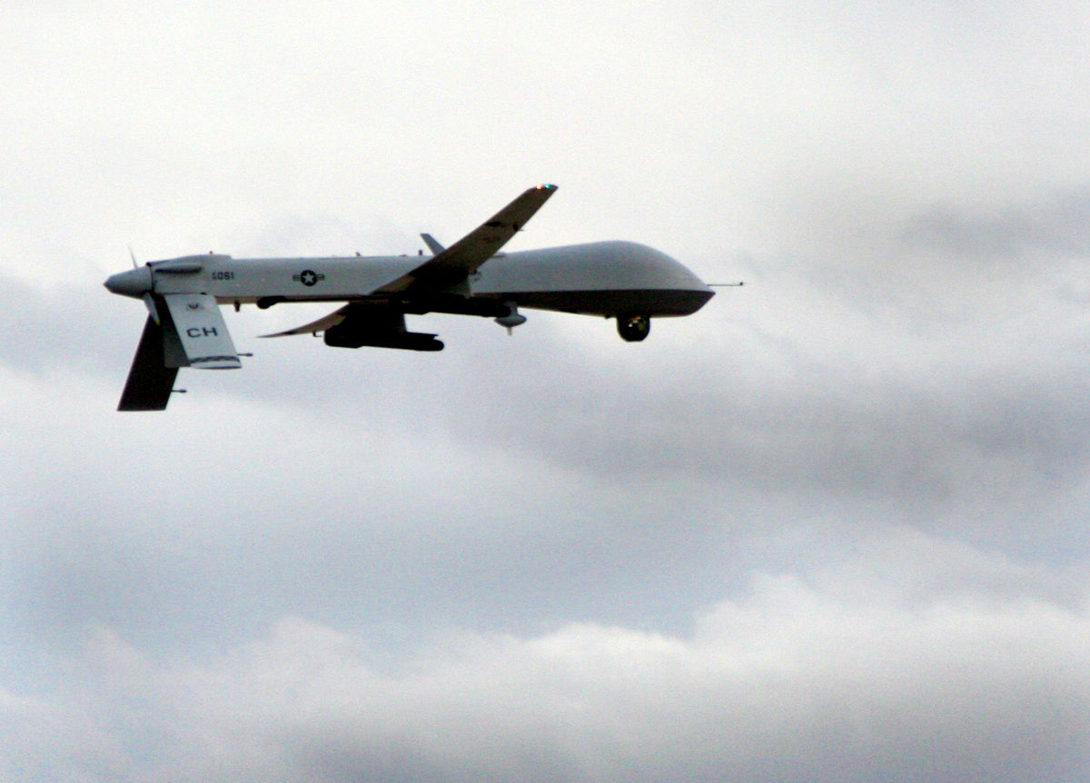

 David Smith / Flickr

What are drones?

Unmanned Arial Vehicles (UAVs), commonly known as “drones” are aerial systems that can be remotely controlled for short and long range military and civilian purposes. Drones are usually equipped with a camera and can also be armed with missiles. While surveillance drones lead to privacy and civil liberties concerns, FCNL focuses primarily on the use of lethal drone strikes.

How does the United States use drones?

The use of drones by the United States government is constantly evolving. Currently, the Central Intelligence Agency (CIA) oversees the [targeted killing program](http://www.thebureauinvestigates.com/category/projects/drones/) which utilizes drones to strike individuals across the globe including in Afghanistan, Pakistan, Yemen, Libya, Somalia, and the Philippines.

How many drones does the U.S. have? How much do drones cost?

According to recent reports, the Pentagon now has some 7,000 aerial drones, compared with fewer than 50 a decade ago. The [fiscal year 2016 budget](http://dronecenter.bard.edu/drones-in-the-defense-budget-2/) included $2.9 billion for drone research, development, and procurement. This figure represents the known costs; it does not include funding that may be classified. The [CIA](http://wapo.st/qqEF2Q) has about 30 Predator and Reaper drones, which are operated by Air Force pilots from a U.S. military base in an unnamed U.S. state. The [Department of Homeland Security](http://californiawatch.org/dailyreport/us-border-drones-generate-lots-buzz-few-results-16637) has at least ten unarmed Predator drones, costing approximately [$62 million](http://www.cbsnews.com/news/homeland-security-drone-program-not-justifying-expense-report-says/) a year. The cost per flight hour varies by type of drone. Predator and Reaper drones cost about $2,500-3,500 per flight hour; larger armed systems such as the military’s Global Hawk cost about 10 times as much: approximately $30,000 per flight hour.

Who do the drones target?

Drone strikes typically target individuals who have been placed on a “kill list” by the administration in a secret process that is not subject to oversight or transparency.

Other strikes known as “signature strikes” are based on vague, suspicious patterns of behavior such as being a man of a particular age or being in a particular location. News reports typically fail to investigate descriptions such as “militants” when describing the known victims of drone strikes. Upon closer inspection, the rationale often crumbles. For example, one official [told the New York Times](http://www.nytimes.com/2012/05/29/world/obamas-leadership-in-war-on-al-qaeda.html?pagewanted=all) that the CIA could see “three guys doing jumping jacks” and consider them to be a part of a terrorist training camp.

What is Congress’ role regarding drones?

Congress’ primary role with respect to the U.S. drones program has been funding research and development and procurement by the U.S. military and the Department of Homeland Security. Congress has exercised little or no oversight related to the tactical or strategic use of drones. Written immediately after the attacks on September 11th, the [60 words that make up the 2001 Authorization for the Use of Military Force (AUMF)](http://www.buzzfeed.com/gregorydjohnsen/60-words-and-a-war-without-end-the-untold-story-of-the-most#.tmoKeevpZ) gave the executive branch unprecedented war powers, and has been used to justify drones strikes across the world. Congress has subsequently failed to adequately question the administration for information regarding drones. In 2014, Senator Ron Wyden [led the effort to ask for more transparency on U.S. drone policy](http://www.scribd.com/doc/231427958/Wyden-Udall-Heinrich-Letter-to-the-White-House-on-Transparency-in-Drone-Policy), but only two other Senators—Mark Udall and Martin Heinrich—signed onto his letter. As a comparison, there were nearly 50 members of Congress on the pro-drones caucus last year. It is now chaired by Rep. Joe Heck (NV) and Daniel Lipinski (IL).

What is the administration’s role regarding drones?

At the National Defense University in 2013, the President reminded Americans that the current [decision to use drones](https://www.whitehouse.gov/the-press-office/2013/05/23/remarks-president-national-defense-university) will ultimately “define the type of nation—and world—that we leave to our children.” According to press reports, however, President Obama personally oversees a so called “kill list” that details who is to be targeted. While the President has called for “[strong oversight of all lethal action](https://www.whitehouse.gov/the-press-office/2013/05/23/remarks-president-national-defense-university),” the administration has yet to release details regarding the aforementioned list. In particular, the administration has failed to share what criteria is currently being used to place individuals on the list, how “signature killings” meet that criteria, and who ultimately approves that list.

What are the long-term implications of the use of drones?

With the lack of overarching strategy, many mistakenly see drones as a low cost—human and financial—alternative to war. By deviating from conventional authorized and specified wars that start and stop, the drones program allows the U.S. to remain in a [constant state of endless war](http://www.stimson.org/images/uploads/research-pdfs/task_force_report_FINAL_WEB_062414.pdf). This shifts the strikes into covert operations with little or no congressional or public oversight, and operating outside of legal norms.

**Drones and "Blowback"**

Evidence suggests that the trauma of living under drones causes anti-American resentment and aids in the recruitment for violent extremism. According to a former State Department official, for every drone strike, the U.S. generates roughly [forty to sixty new enemies](http://www.aucegypt.edu/gapp/cairoreview/Pages/articleDetails.aspx?aid=443). Such long term damage is known as “blowback” – incidents that arise in later years as an unintended consequence of actions taken today.

**Effects on Drone Pilots**

This new form of war has also had unprecedented effects back home; not only do drone pilots experience mental health problems at the same rate as their counterparts in Iraq and Afghanistan, [recent studies suggest](http://www.thenation.com/article/200337/american-drone-operators-are-quitting-record-numbers) that drone pilots may be experiencing a new form of psychological strain—a long distance version of post-traumatic stress syndrome (PTSD). Despite working thousands of miles from the battlefield, many drone pilots experience anxiety, depression, and severe stress. Moreover, citing extraneous hours—often between 900 and 1,800 hours a year, compared to the maximum 300 hours that regular Air Force pilots work—drone pilots are [quitting in record numbers](http://www.thenation.com/article/200337/american-drone-operators-are-quitting-record-numbers).

**The Future of Drones and Warfare**

It is time to pause and evaluate the potential outcomes of this policy. Currently, [hundreds of companies are developing small and large scale drone technology](http://n.pr/NnUygX). At last count, [more than 50 countries are developing drones](http://www.rand.org/content/dam/rand/pubs/research_reports/RR400/RR449/RAND_RR449.pdf), and more than 70 countries have already acquired various types. Experts suggest that every country will possess the ability [to create or acquire armed drones](http://www.defenseone.com/technology/2014/05/every-country-will-have-armed-drones-within-ten-years/83878/) within ten years. This February, the Obama administration announced that it would soon allow for the [export of armed drones](http://www.washingtonpost.com/world/national-security/us-cracks-open-door-to-the-export-of-armed-drones-to-allied-nations/2015/02/17/c5595988-b6b2-11e4-9423-f3d0a1ec335c_story.html?postshare=3691424209259814) to allies.

If drones lower the threshold for war, what happens when everyone has drones? What happens when the United States no longer has a monopoly on this technology? The U.S., in conjunction with the international community, will benefit from recognizing this potential and beginning to outline restrictions and accountability for drone use. Restricting the use of drones worldwide is undoubtedly in the best interest of a more peaceful world.